5G/6G Communication Systems- ECA5601 (LAB)
Student Name: A.SAI KIRAN
Reg no: 192312672L
Experiment 3: -Spectrum Analysis of Sub-1 GHz, Mid-band & mm Wave by Plotting Propagation Loss.
AIM: To analyse the propagation loss characteristics of different frequency bands (Sub-1 GHz, Mid-band, and mm Wave) in wireless communication systems and compare their performance over varying distances using MATLAB.
Objective :
1. To compute the Propagation Loss (dB) for Sub-1 GHz, Mid-band, and mmWave
frequency ranges using standard path loss models.
2. To evaluate the impact of different Operating Frequencies (GHz) on signal attenuation
and coverage performance.
3. To analyze how Communication Distance (km) affects propagation loss across
different spectrum bands.
Procedure
1. Define frequency bands: Sub-1 GHz (0.9 GHz), Mid-band (3.5 GHz), and mmWave (28
GHz).
2. Set communication distance range (e.g., 0.1 km to 5 km).
3. Use Free Space Path Loss (FSPL) formula to compute propagation loss:
PL(dB)=20log⁡10(d)+20log⁡10(f)+32.44
4. Calculate propagation loss for each frequency band over varying distances.
5. Plot distance vs propagation loss curves for comparison.
6. Analyze how higher frequencies experience higher attenuation.
7. Compare coverage efficiency of each spectrum band.
8. Display results using MATLAB plots.

Objective 1:
MATLAB Code:
clc; clear; close all; d = 0.1:0.1:5; % Distance (km) f = [900 3500 28000]; % Frequency (MHz)
PL1 = 32.44 + 20*log10(f(1)) + 20*log10(d);
PL2 = 32.44 + 20*log10(f(2)) + 20*log10(d); PL3 = 32.44 + 20*log10(f(3)) + 20*log10(d); figure
% -------- Graph 1 -------- subplot(2,1,1)

plot(d,PL1,'b','LineWidth',2); hold on plot(d,PL2,'r','LineWidth',2) plot(d,PL3,'k','LineWidth',2) title('Propagation Loss vs Distance') xlabel('Distance (km)') ylabel('Loss (dB)') grid on
% -------- Graph 2 (NO legend used to avoid error) -------- subplot(2,1,2)
Freq = [900 3500 28000]; Loss = [PL1(10) PL2(10) PL3(10)]; plot(Freq,Loss,'-o','LineWidth',2) title('Propagation Loss vs Frequency') xlabel('Frequency (MHz)') ylabel('Loss (dB)') grid on
Output:
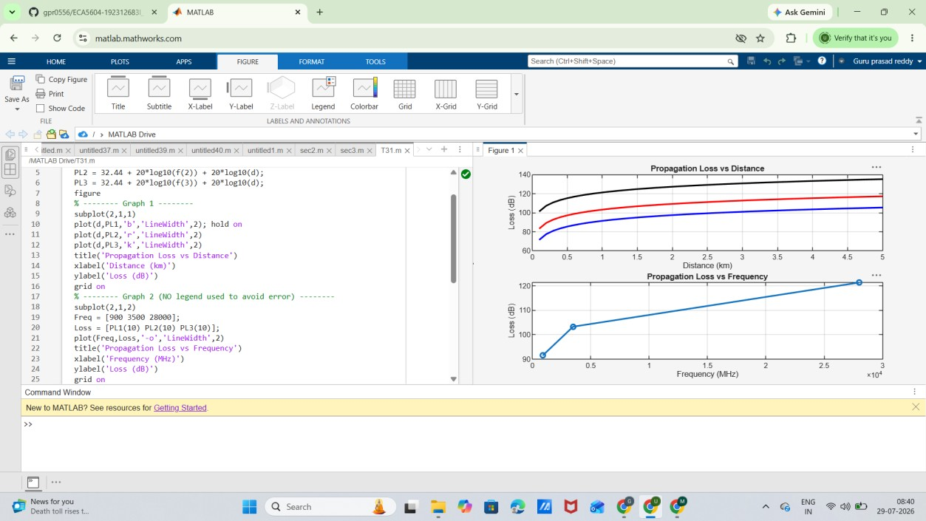
Objective 2:
MATLAB Code:
clc; clear; close all; d = 2; % fixed distance (km)

f = [900 3500 28000]; % MHz
PL = 32.44 + 20*log10(f) + 20*log10(d); figure
% -------- Graph 1: Frequency vs Loss -------- subplot(2,1,1)
plot(f,PL,'-o','LineWidth',2) title('Propagation Loss vs Operating Frequency') xlabel('Frequency (MHz)') ylabel('Propagation Loss (dB)') grid on
% -------- Graph 2: Band Comparison -------- subplot(2,1,2) bar(PL) title('Comparison of Propagation Loss Across Bands') xlabel('Frequency Bands (Index: 1=Sub-1GHz, 2=Mid-band, 3=mmWave)') ylabel('Propagation Loss (dB)') xticklabels({'Sub-1GHz','Mid-band','mmWave'}) grid on
Output:
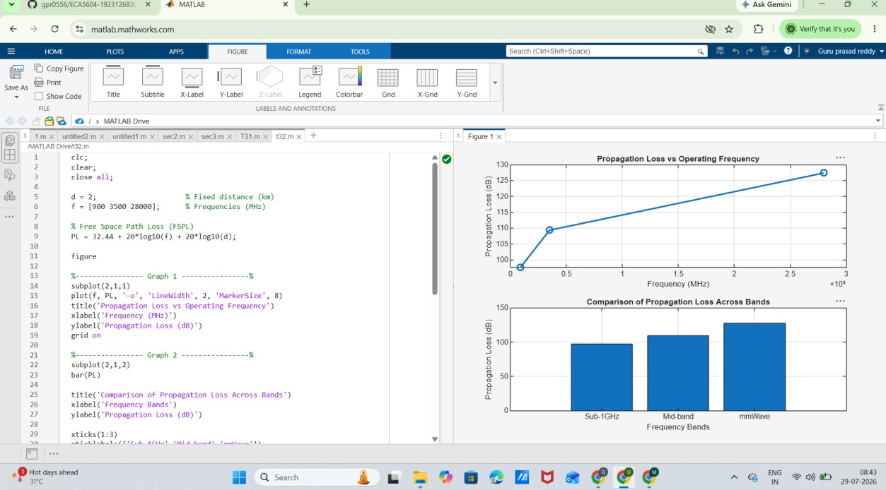

Objective 3: Matlab Code and Output:
clc; clear; close all;
% Frequency bands (MHz) f = [900 3500 28000]; % Distance (km) d = 2;
% Propagation Loss (FSPL)
PL = 32.44 + 20*log10(f) + 20*log10(d); figure
% -------- Graph 1: Simple Line Plot (SAFE) -------- subplot(2,1,1) plot(f, PL, '-o', 'LineWidth', 2) title('Propagation Loss vs Operating Frequency') xlabel('Frequency (MHz)') ylabel('Propagation Loss (dB)') grid on
% -------- Graph 2: Safe Comparison Plot -------- subplot(2,1,2) plot(1:3, PL, '-s', 'LineWidth', 2) title('Band-wise Propagation Loss Comparison') xlabel('Band Index (1=Sub1GHz, 2=Mid-band, 3=mmWave)') ylabel('Propagation Loss (dB)') grid on

Output:
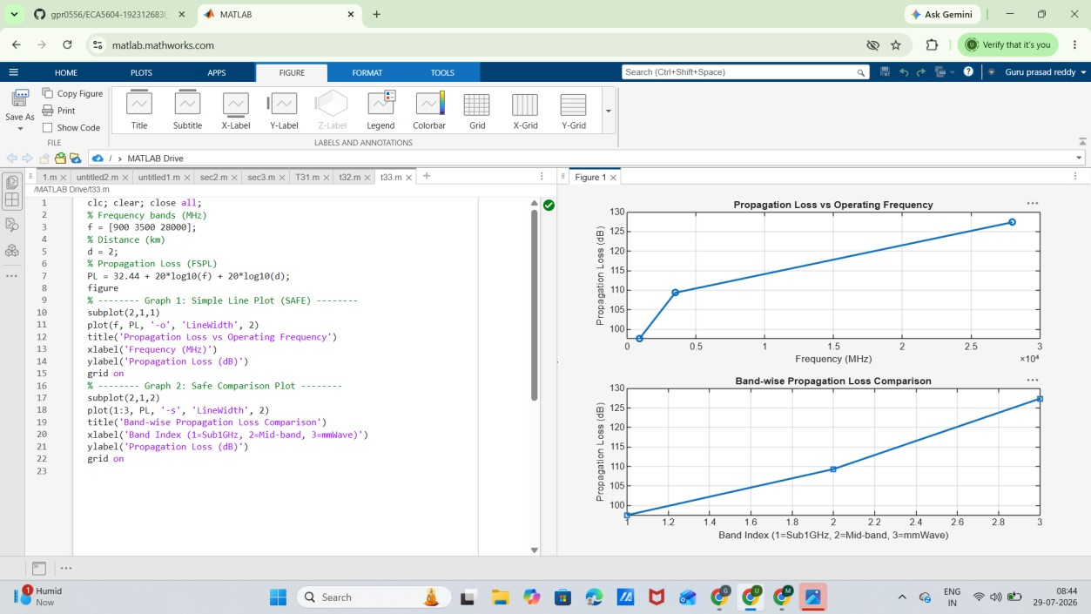

Result: The propagation loss for Sub-1 GHz, Mid-band, and mm Wave frequency bands was successfully analysed using MATLAB. The results showed that propagation loss increases with both frequency and communication distance, with mm Wave experiencing the highest attenuation and Sub-1 GHz providing the best coverage.

